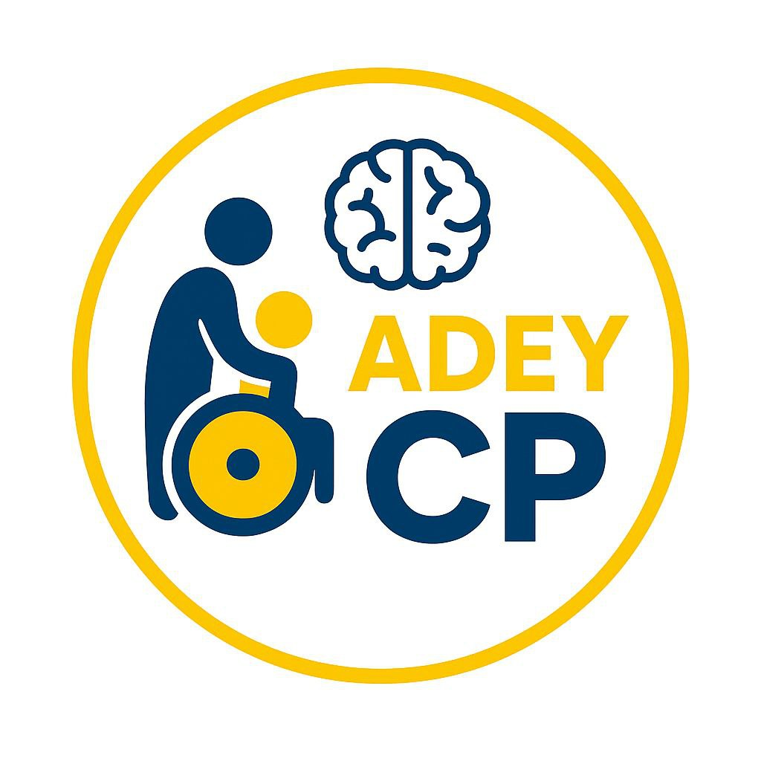

Safeguarding Policy

Adey Cerebral Palsy Charitable Association
This Safeguarding Policy of Adey Cerebral Palsy Charitable Association commits to protecting children, caregivers, staff, and communities from abuse, exploitation, fraud, and unethical behavior.
It sets clear standards and accountability measures to ensure dignity, inclusion, and safety in all aspects of our work.

Safeguarding Policy
Adey Cerebral Palsy Charitable Association (Adey CPCA) is committed to the highest standards of integrity, transparency, and accountability. Recognizing that fraud, corruption, and unethical behavior undermine trust, waste resources, and harm beneficiaries, Adey has established clear mechanisms to prevent, detect, and respond to such risks.

Key Mechanisms

1. Governance Oversight
- The Board of Directors provides strategic oversight and ensures compliance with Ethiopian civil society regulations.
- Regular board reviews of financial reports, procurement decisions, and risk assessments safeguard against misuse of resources.

2. Financial Controls
- Strict budgeting, cash handling, and procurement procedures are in place.
- All expenditures require multi-level authorization and are documented for transparency.
- Annual independent audits verify financial integrity and donor compliance.

3. Code of Conduct
- All staff, volunteers, and partners must sign Adey’s Code of Conduct, which prohibits fraud, bribery, favoritism, and misuse of funds.
- Violations result in disciplinary action, including termination and legal referral.

4. Conflict of Interest Policy
- Staff and board members must disclose any personal or financial interests that could influence decision-making.
- Transactions involving potential conflicts are reviewed independently to ensure fairness.

5. Whistleblower Protection
- Confidential reporting channels allow staff, caregivers, and community members to report suspected fraud or unethical behavior.
- Whistleblowers are protected from retaliation and supported throughout investigations.

6. Procurement and Asset Management
- Transparent procurement guidelines ensure fair competition and value for money.
- Asset registers and inventory controls prevent theft, loss, or unauthorized use of organizational property.

7. Training and Awareness
- Staff receives regular training on anti-corruption policies, ethical decision-making, and donor compliance.
- Awareness campaigns reinforce a culture of integrity and accountability.

8. Monitoring and Evaluation
- Internal monitoring systems track program implementation and financial flows.
- Spot checks and field visits detect irregularities and ensure resources reach intended beneficiaries.

Organizational Culture and Commitment
Adey fosters a culture of ethical leadership, where transparency and fairness are central to its mission. Staff is encouraged to speak up, ask questions, and challenge unethical practices. The association works closely with donors, government bodies, and community stakeholders to uphold trust and credibility in all its activities.

